<https://www.youtube.com/watch?v=AK6Rf_yjvI0>

<https://www.youtube.com/watch?v=AK6Rf_yjvI0>

Create access keys as below

Create java class in config folder and do below configuration.

Create topic as below.

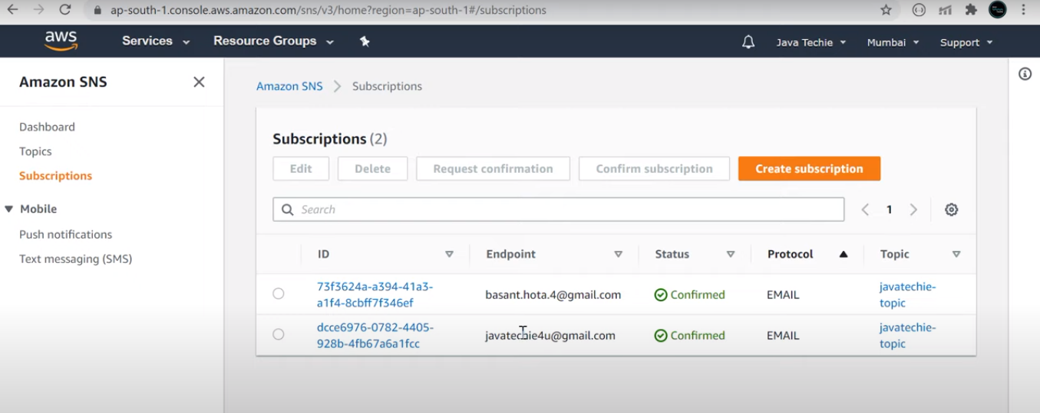

We need to add some plugin due to some size limit

Create Function in AWS Console and given requestHandler class.

Upload your reduced size jar as below.

<https://aws.plainenglish.io/deploying-spring-boot-web-application-on-aws-ec2-instance-27d016dea0f1>

<https://cloudkatha.com/how-to-deploy-spring-boot-application-on-aws-ec2/>